**srcML Tool Implementation on a C# Environment**

Jesus Eduardo Jaime Gandarilla

Department of Computer Science

The University of Texas at Dallas

[jxj132730@utdallas.edu](mailto:jxj132730@utdallas.edu)

**1. Introduction**

This project’s main goal is to detect Common Coupling in a C# language code base using the set of tools provided by the srcML Framework.

Coupling is defined as a measure of interdependence among modules in a computer program [1]. In our case we chose, Common Coupling, also know as Global Coupling which occurs when two modules share the same global data or variable.

On the other hand, srcML is an infrastructure for the exploration, analysis, and manipulation of source code [2] which translates code from a project in Java, C++, C or C# into a single XML format document. All original text is preserved so that the original source code documents can be recreated from the XML file [3] and even keeping the directory structure of the project. The latest version of this toolkit was posted in May, 2015.

**2. Implementation**

As a first step, we searched the different options available to carry out code analysis for a project in C# and more precisely, with the intention to use these tools inside a Visual Studio Project to create an automated tool for code analysis.

At the end of the day, we found that there are three viable options to implement srcML in a C# code base.

**2.1 Option 1 - Command Line Tool**

This is the tool available to download in the project's website: srcml.org. The installation and use is very simple:

1. Go to [www.srcml.org](http://www.srcml.org)
2. Click on Downloads
3. Select the version for your OS
4. Install the executable.
5. Open a command line.
6. Execute srcML command as shown in figure 1.

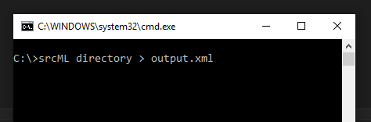

Figure 1. Converting a project into a single xml file in srcML Format.

This toolkit also offers the following commands:

1. src2srcml: Converts a directory or a file in any of the supported programming languages into a XML File in srcML Format.
2. srcml2src: Converts a XML File in srcML Format into a file or project files in the original programming language and preserving directory structure.
3. xpath: By passing a XPATH query we can get nodes in the XML File.

In our case, we will not implement this option since we are interested in creating a tool in Visual Studio to automate this process.

**2.2 Option 2 - As a Visual Studio Service**

srcML Service can be installed in Visual Studio by click on tools, selecting extensions and updates and then looking for it in the online tab.

This option provides analysis services for other visual studio extensions to consume. It is useful if you want to develop Visual Studio plugins, such as Sando Search tool which is an improved text search tool, also sponsored by ABB Research Center and uses srcML Service to get notified of file changes. [4]

This option is not useful for our project’s needs. However, it is worth mentioning so that the audience know that there are some standalone tools that implement srcML.

**2.3 Option 3 - As a package in a Visual Studio Project.**

ABB Research Center provides a framework that they have been using within themselves to do both program transformation and code analysis.

This framework is named srcML.NET, and can be downloaded using GitHub or directly ‘installed’ into a Visual Studio Project using the Package Management Console.

To do so, one must follow the following steps:

1. Open visual studio and create a new project.
2. Click on View > Other windows > Package Management Console
3. Enter the following command:

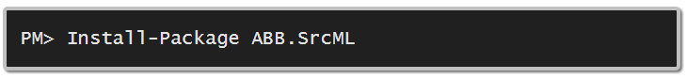

1. Now you can import ABB.SrcML and code a small tool. Figure 2 shows an example of how to create an instance of the ABB.SrcML class that converts a project into a srcML XML File.

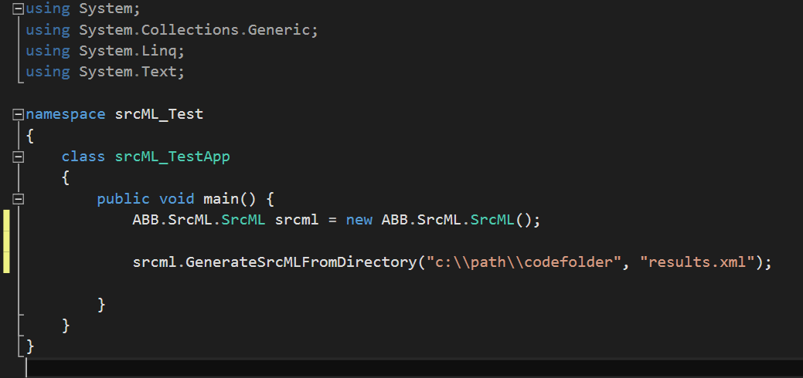

Figure 2. Creating a class that converts a project into an XML file.

In this project, we will choose this options as it is the one that fits best our goals:

1. Create a small tool that converts a project in C# into a XML file in srcML Format.
2. Provide code analysis capabilities with the same tool in order to detect Common Coupling in the project.

**2.4 More on ABB srcML.NET**

srcML.Net is a framework used within ABB Corporate Research and it’s based on the srcML project from Kent State University Software Development Laboratory.

It is used to do both program transformation and code analysis, and includes the same tools and functionality offered by srcML but allows integration to Visual Studio Projects to develop code analysis tools. [5]

**3. Projects to be analysed in this project**

We have completed the first step in this project which is converting a code base in C# into a single XML file in srcML Format.

As you can see in table 1, the conversion from C# to srcML inputs a XML file that is between 2.5 and 2.8 times larger than the code base. In our biggest size project, Mono, the output XML file is 455 MB in size which is still considered, in our opinion, a processable size and does not require splitting the file into more files.

The Mono project took around a minute to be converted into XML and all the others were converted almost instantly by the tool.

|  |  |  |  |
| --- | --- | --- | --- |
| **Project** | **Number of .cs files** | **Total Size (MB)** | **Total Size of XML** |
| CodeHub | 344 | 1.64 MB | 4.55 MB |
| MonoGame | 1,229 | 9.24 MB | 24 MB |
| Newtonsoft.Json | 2,014 | 2.46 MB | 6.57 MB |
| Mono (<1min) | 24,819 | 161 MB | 455 MB |

Table 1: Code base conversion results

It is also worth mentioning that, for our analysis and tool creation, we will be using a computer with the following characteristics:

* 6th Generation Intel Quad Core i7 Processor
* 16 GB DDR4 of RAM memory.

**4. Structure of the selected approach**

In this section we will define the structure of the selected approach for the implementation of srcML in a C# environment.

After some tests we found out that the functions available through srcML.NET help to convert the code base easily from source code to srcML format. However, the functionality available to query the file is more complex than the standard XPath implementation of the .NET Framework.

For this reason, and because we wanted to keep the implementation as simple as possible, we chose to go on and create a tool in C# and Visual Studio which loaded the converted code base in srcML XML Format and offered querying capabilities.

The tool shall offer the following functions:

1. Load a XML file in srcML Format.
2. Execute custom queries using the XPathDocument class available in the .NET Framework.
3. Execute a specific scan type:
   1. Detect Common Coupling with Method granularity.
   2. Detect Common Coupling with File granularity
4. Convert a folder to srcML Format

**5. Analysis of the Code Bases**

The next step was to analyse a code base sample in order to detect the attributes and tags that we want to identify and then based on this information, generate the XPATH queries necessary for our tool:

By taking a look at the srcML File structure, we identified the following components:

**Units (Files)**

Units represent the individual source code files by using the tag <unit>. Some attributes like language and filename add useful information to identify the file.

Each unit includes, among other components, comments, blocks of code, declaration statements, and functions. The following is an example of the <unit> tag:

<**unit** xmlns:cpp="http://www.srcML.org/srcML/cpp" revision="0.9.5"  
 **language**="C#"   
 **filename**="ConstructorHandling.cs"  
 hash="336e2f0959f373b22eab5cdef109f7a2d72c196a">  
 <**decl_stmt**>(Declaration statement)</decl_stmt>  
 <**function**>(Method definition)</function>  
</unit>

**Variable Declarations**

The variable declaration statement is simply represented by the tag <decl_stmt> and includes components like type and name. The following example represents the declaration **“int myInt;”** :

<**decl_stmt**>

<**decl**>

<**type**> <name>int</name> </type>

<**name**>myInt</name>

</decl>;

</decl_stmt>

Function Structure

A function is represented by the tag <function> and includes the specifiers such as static or private, type, name and a code block that contains methods calls, variable declarations, etc.

The following example represents the function **“static void doWork() { CODE BLOCK... }”:**

<**function**>

<**specifier**>static</specifier>

<**type**> <name>void</name> </type>

<**name**>doWork</name>

<parameter_list>()</parameter_list>

<**block**> { (Comments, variables declarations and method calls) } </block>

</function>

**XPath Querying**

After getting familiar with the XML Structure used by srcML, we proceed to code the first path of the tool in order to offer simple custom query capabilities. The following table shows the results of this process, when we were finally able to retrieve a list of filenames, declared fields, and declared methods in the code base:

|  |  |
| --- | --- |
| **Objective** | **XPath Expression** |
| Get all the files in the code base. | //src:unit/src:unit |
| Get filename for each unit. | //src:unit/@filename |
| Get all the fields. | //src:class/src:block/src:decl_stmt/src:decl/src:name |
| Get all the methods that use those fields. | //src:function[descendant::src:name='FIELDNAME']/src:name |

**Code Analysis Results**

MENCIONAR QUE QUISE MANTENER TODO LO MÁS SIMPLE QUE PUDE

Resear Questions srcML.NET

- How to detect coupling? is there a formula? pattern?

- Detech method granularity coupling

- Discuss the test data/ Find the ones that are unexpected

- Global variables vs data in a external source.

SA

**6. Conclusion and Future Work**

During this project we found out that srcML can easily be implemented in any programming language that you like. Java, C#, VB.NET, or whatever language with XPath support to design your code analysis tools.

srcML makes it really simple to analyse the code and it was a huge difference from the Java JDT approach. The main difference is that when using srcML you are dealing with an XML document and the implementation of XPath expression makes it really easy to query the document and get the desired information.

In our future work, we would like to expand our tool’s functionality in order to offer different kinds of analysis and even include analysis of JAVA code.

**References**

[1] IEEE, Guide to the Software Engineering Body of Knowledge (SWEBOK v3), 2014.

[2] srcML.org Home Page. Retrieved from: [http://www.srcml.org/](http://www.srcml.org/doc/cs_srcML.html)

[3] Collard, M. L. and Maletic, J. I., "Lightweight Transformation and Fact Extraction with the srcML Toolkit.", 2011.

[4] Visual Studio Gallery. Retrieved on April 14th, 2016 from: <https://visualstudiogallery.msdn.microsoft.com/ca1c4937-170f-472b-b251-11a9f4d2a161>

[5] srcML GitHub repository. Retrieved from: <https://github.com/abb-iss/SrcML.NET>